Nepal college of information echnology
Assessment
Level: Bachelor | Semester – Fall | Year : 2015
Programme: BE-IT Day Morning |  | Full Marks : 100
Course: Signal & System Processing |  | Time : 3hrs.
Candidates are required to give their answers in their own words as far as practicable.
The figures in the margin indicate full marks.

Attempt all the questions.

1. a) Determine the Fourier Transform of an exponentially decaying signal
x(t) = e^{-at} u(t), a>0. 7
b) Find the output of the system with impulse response h[n]={1,2,-1,1} to the input x[n]={1,2,3} using convolution
↑ ↑ 8
sum.
2. a) Find out the z-transform of following function. Also indicate ROC 8
i) x[n] = (2)^{n} u[n]
ii) x[n]=cosw₀n
b) Find out the inverse z-transform of following expression 7
H(z) = 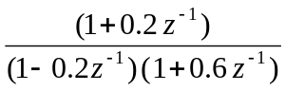
3. a) Find the homogeneous response of the system y[n] – 3y[n-1] – 4y[n-2] =0 with initial conditions y[-1]=0.5 ,y[-2]=0.25. 8

b. Determine the lattice coefficients corresponding to the FIR filter with system function H(z)= A₃(z)= 1+ 1/3z⁻¹ + 1/4 z⁻² + 1/2 z⁻³ and draw the lattice structure also. 7

4. a) Realize the following system by its direct form I and form II structure 7
y[n]= x[n] – 0.2x[n-1] + 0.5x[n-2] + 0.8 y[n-2]

b) Design a digital low pass Butterworth filter using Bilinear Transformation method to meet the following specification
Passband edge frequency= 1.25 KHz 8
Stopband edge frequency= 2.33 KHz
Passband Ripple ≤ 0.5 dB
Stopband Attenuation ≥ 14 dB
Sampling frequency = 10 KHz
5. a) Convert the analog filter with system function 7 H_{a}(s)= 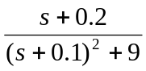into a digital filter by means
of Impulse Invariance method.
b) Explain the rectangular window method to design FIR filters? How do Gibb’s Phenomena occur in FIR filter design. 8
6. a) Define circular convolution. Perform the 4-point circular convolution of sequences
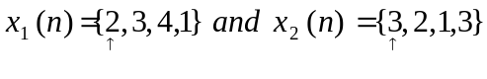 7
b) Find 8-point DFT of the sequence 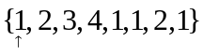using radix-2 DIT algorithm. 8

7. Write short notes on: (Any two ) 2×5
a) Limit Cycle Oscillation
b) Discrete Fourier Transform
c) Chebysheb Filter
d)Energy and Power signal

